**CS105:**

**COMPILER DESIGN PROJECT**

**Group C4:**

Arioja, Ryan

Dela Pena, Ezekiel

Lara, Andrea

Leabres, Kimberly

Porciuncula, Bianca

Saliba, Allison

Zurita, Kevin

**4CSC**

**Phase I. Programming Language Design**

**Requirements:**

1. ***Character set***

The language uses a subset of the UTF-8 encoding, which includes uppercase and lowercase letters, numbers, and some special characters.

∑ = {[A-Z], [a-z], [0-9], [; = + - * / \ | & < > ( ) { } # : ‘ . , % ^ ! @ ~ ` $ “] }

* ***Case-sensitivity***

The language is case-sensitive.

* ***Control characters***

The \n is for newline.

The , seperates parameters.

The ; seperates multiple statements in a single line of code.

1. ***White spaces:***

* ***Spaces, tabs, end-of-line, and end-of-file***

The language allows spaces, end-of-line char, and end-of-file char. It doesn’t allow tabs.

* ***Comments***

For one-line comment, it is indicated by a #comment at the beginning. For block comments, it is indicated by placing a #comment then the following lines will now be considered as a comment. The following lines must be indented 2 spaces.

Ex.

#comment This is a one-line comment.

#comment

This is a block comment.

This is a block comment.

#comment This line is indented.  
   
#comment This  
 is  
 valid.

#comment This  
 is  
 not valid.

#comment  
 This is  
not valid.

* ***Control characters***

Each line must end with a line break or a newline character. No trailing whitespaces must appear after each line. The file must end with a newline.

1. ***Start, end, and program name:***

The reserved word #login indicates the start of the program while the reserved word #logout indicates the end of the program. The name of the program will be placed after #login.

Ex.

#login HelloWorld  
 …  
#logout

1. ***Tokens***

* A statement (except #login and #logout) usually begins with an even number of spaces before them because of the two-space indention.
* Reserved words usually begin with a hash (#) symbol.
* Tokens may end with a space, EOL, EOF, or a delimiter.

**Division Tokens**

|  |  |  |
| --- | --- | --- |
| **Lexemes** | **Token Names** | **Description** |
| #login | START | Program start |
| #logout | END | Program end |
| #newsfeed | MAIN | Main function |
| #trending | PROC_CALL | Function call |
| #throwback | PROC_RET | Function return |
| #share | ASSIGN | Assignment statement |
| #comment | COMMENT | Comment |
| areFriendsWith | CONCAT | String concatenate |
| identifiers | VAR | Variable name |

**Data Type Tokens**

|  |  |  |
| --- | --- | --- |
| **Lexemes** | **Token Names** | **Description** |
| #ooti | DATATYPE_INT | Integer data type |
| #ootf | DATATYPE_FLOAT | Float data type |
| #ootc | DATATYPE_CHAR | Character data type |
| #oots | DATATYPE_STRING | String data type |
| #ootb | DATATYPE_BOOL | Boolean data type |
| #ootv | DATATYPE_VOID | Void data type |

**Loop Statement Tokens**

|  |  |  |
| --- | --- | --- |
| **Lexemes** | **Token Names** | **Description** |
| #like | DO | do |
| #status | WHILE | while |
| #unfollow | BREAK | break |
| #follow | CONTINUE | Continue |

**Conditional Statement Tokens**

|  |  |  |
| --- | --- | --- |
| **Lexemes** | **Token Names** | **Description** |
| #tweet | IF | if statement |
| #retweet | ELSE_IF | else if statement |
| #reply | ELSE | else statement |

**Input and Output Tokens**

|  |  |  |
| --- | --- | --- |
| **Lexemes** | **Token Names** | **Description** |
| #inbox | INPUT | Stream input |
| #outbox | OUTPUT | Stream output |

**Constants Tokens**

|  |  |  |
| --- | --- | --- |
| **Lexemes** | **Token Names** | **Description** |
| ([0-9])* | INT_CONST | Integer constant |
| ([0-9])*.([0-9])* | FLOAT_CONST | Float constant |
| ‘([A-Z]|[a-z]|[0-9]|[SPEC_CHARS])’ | CHAR_CONST | Character constant |
| “([A-Z]|[a-z]|[0-9]|[SPEC_CHARS])*” | STRING_CONST | String constant |
| accept | BOOL_CONST_TRUE | Boolean true |
| decline | BOOL_CONST_FALSE | Boolean False |
| null | NULL | Null constant |

**Arithmetic Operator Tokens**

|  |  |  |
| --- | --- | --- |
| **Lexemes** | **Token Names** | **Description** |
| ++ | INC_OP | Increment operator |
| -- | DEC_OP | Decrement operator |
| + | ADD_OP | Addition operator |
| - | DIF_OP | Difference operator |
| * | MUL_OP | Multiplication operator |
| % | MOD_OP | Modulo operator |
| / | DIV_OP | Division operator |
| ^ | EXP_OP | Exponential operator |
| ( | LEFT_PAREN | Left Parenthesis |
| ) | RIGHT_PAREN | Right Parenthesis |

**Relational and Logical Tokens**

|  |  |  |
| --- | --- | --- |
| **Lexemes** | **Token Names** | **Description** |
| || | OR_OP | Short circuit OR |
| && | AND_OP | Short circuit AND |
| < | LESS_OP | Less than operator |
| > | GREAT_OP | Greater than operator |
| <= | LESS_EQ_OP | Less than or equal operator |
| >= | GREAT_EQ_OP | Greater than or equal operator |
| == | EQUAL_OP | Equal operator |
| != | NOT_EQUAL_OP | Not equal operator |
| ! | NOT_OP | NOT operator / Boolean toggle operator |

**Other Tokens**

|  |  |  |
| --- | --- | --- |
| **Lexemes** | **Token Names** | **Description** |
| = | ASSIGN_OP | Assignment operator |
| , | PARAM_SEP | Parameter separator |
| ; | STMT_SEP | Statement separator |
| two spaces (“ “) | INDENT | Scope indent / Nesting indent |
| “ | DQUOTE | Double quote |
| ‘ | SQUOTE | Single quote |

* ***Reserved words***

|  |  |  |
| --- | --- | --- |
| areFriendsWith | ootb | retweet |
| comment | ootc | share |
| follow | ootf | status |
| inbox | ooti | throwback |
| like | oots | trending |
| login | ootv | tweet |
| newsfeed | outbox | unfollow |
| null | reply |  |

1. ***Data types for identifiers and constants***

The data types included are ooti, ootf, ootc, oots, ootb, and ootv.

|  |  |
| --- | --- |
| ooti | integers |
| ootf | float |
| ootc | char |
| oots | string |
| ootb | boolean |
| ootv | void |

* ooti is the data type for whole numbers.
* ootf is the data type for bigger and more precise numbers. Its precision will be at most 15 digits.
* ootc is the data type that holds a single character enclosed with single quotation (‘ ‘) marks.
* oots refers to a string of characters, or an array of ootc, and enclosed with double quotation (“ ”) marks.
* ootb refers to a logical type of data that only have two values: accept which means true, and decline which means false.
* ootv is the data type for the result of a function that returns normally, but does not provide a result value to its caller.
* ***Identifiers***

They must consist of alphanumeric characters and an underscore. The first character can start only with a letter or an underscore. Camel case convention is encouraged.

***Regular Expression:***

([a-z] | [A-Z] | _) ● ([a-z] | [A-Z] | [0-9] | _)*

***Declaration:***

#<data_type> <identifier>

Ex.

#ooti sum  
#ootf salary

* ***Constants***

Initialization of constants are not allowed while declaration. Assignment of values must be done explicitly with an assignment operator right after declaring the variable.

***Regular Expression:***

ooti *(integers):* ([0 – 9])*

ootf *(float):* ([0 – 9])*.([0 – 9])*

ootc *(char): ‘*([a-z] | [A-Z] | [0-9] | [@,#,$,…])’

oots *(string): “*([a-z] | [A-Z] | [0-9] | [@,#,$,…] | whitespaces)*”

ootb *(boolean):* (accept | decline)

* ***Initialization***

#<data_type> <identifier> = <value> | <expression>

Ex.

#oots name = “Cecil”  
#ootc yes = ‘Y’

1. ***Statement seperators***

A statement can end with a newline or line break. If two or more statements are present in a line, semicolons (;) must be used as a delimiter to separate each statement. Commas (,) are used to separate expressions and parameters inside parentheses ().

Ex.

#outbox “Hi!”; #outbox “Hello!”

#inbox response; #comment Line comments are needed to be

separated. This line is a valid comment too.

#ootv saiyan(#oots goku, #oots vegeta)

1. ***Blocks***

Off-side rule is implemented to express blocks. Any non-whitespace token to the left of the first such token on the previous line is taken to be the start of a new declaration. Two spaces ( ) is the standard token to be used for indention. The depth of indention indicates scope of a code block. Variables declared in a block have their scope only limited within the block.

Ex.

#ootb isEven(#ooti a)

#tweet (a % 2 == 0)

#outbox “Even!”

#throwback accept

#outbox “Odd!”; #throwback decline

Proper indentation must be followed; else an error will be thrown. Every block level must be indented by two spaces only. Each indent will be matched by a dedent token, which closes the block scope.

1. ***Data conversion***

All cast operations are implicit depending on the declared data type used for the variable. I/O operations are all done in string. Void data type cannot be converted to anything.

* + ***String***

All outputs are implicitly converted into string, regardless of data type. Values of arithmetic expressions are solved before outputted. Boolean literals used for I/O are converted to true for accept, and false for decline. Any data type concatenated with areFriendsWith will be automatically converted to string.

* + ***Integer, Float***

Any input of numbers is automatically converted to integer or float (depending on the declared data type).

1. ***I/O statements***
   * ***Input***

#inbox <identifier>

Ex.

#ooti age

#inbox age

* + ***Output***

#outbox <expression>

Ex.

#characters hello = “Hello World!”

#outbox hello; #comment This prints “Hello World!”

#outbox 3 + 7; #comment This prints 10

#outbox 3 areFriendsWith 7; #comment This prints 37

1. ***Assignment Statements***

#share <identifier> <value>|<expression>

Ex.

#share one 1

#share sum #trending add(num1, num2)

1. ***Conditional Statements***
   * ***tweet-then statement***

It tells your program to execute a certain section of code only if a particular test evaluates to accept.

#tweet (condition)

<statement> | <statements>

Ex.

#ootv brakeCar()

#comment the "tweet" clause: car must be moving

#tweet (isMoving)

#comment the "then" clause: decrease current speed

currentSpeed--

It can be executed in one line, provided that the “then” clause contains only a statement.

Ex.

#ootv brakeCar()

#tweet (isMoving) currentSpeed--;

* + ***tweet-then-reply statement***

This statement provides a secondary path of execution when a #tweet clause evaluates to decline.

#tweet (condition)

<statement> | <statements>

#reply

<statement> | <statements>

Ex.

#ootv brakeCar() {

#tweet (isMoving)

currentSpeed--;

#reply

#outbox “The car has stopped.”

Provided with a condition for the secondary path, a #retweet clause can be used.

#tweet (condition)

<statement> | <statements>

#retweet (condition)

<statement> | <statements>

Ex.

#ooti testScore = 76

#ootc grade

#tweet (testscore >= 90) grade = 'A'

#retweet (testscore >= 80) grade = 'B'

#retweet (testscore >= 70) grade = 'C'

#retweet (testscore >= 60) grade = 'D'

#reply

grade = 'F'

Using the most closely nested rule, any #reply shall be associated with the nearest #tweet without a matching #reply.

1. ***Looping Statements***

* ***status loop***

The #status statement continually executes a block of statements while a particular condition is true.

#status (expression)

<statement> | <statements>

The #status statement evaluates expression, which must return a boolean value. If the expression evaluates to accept, the #status statement executes the statement(s) in the #status block. It continues testing the expression and executing its block until the expression evaluates to decline.

Ex.

#ooti count = 1

#status (count < 11)

#outbox “Count is: “ areFriendsWith count

count++

* ***like-status loop***

The #like - #status statement is a variant of the #status statement.

#like

<statement> | <statements>

#status (condition)

The statement block is first executed, and then the condition is evaluated. If the condition returned a accept value, the first statement in the #like - #status will be again executed. The statement block will be executed continuously until the condition returns a decline value.

Ex.

#ooti count = 1

#like

#outbox “Count is: “ areFriendsWith count

count++

#status (count < 11)

1. ***Branching Statements***
   * ***unfollow statement***

If the #unfollow statement is encountered inside any looping constructs, the rest of the statement block will be skipped and the statement following the statement block will be executed.

Ex.

#ooti count = 1

#status (count < 11)

#outbox “Count is: “ areFriendsWith count

#tweet (count == 3) #unfollow

count++; #comment Will be skipped at count = 3

* + ***follow statement***

It allows prematurely terminating the current loop body and returning the program control back to the beginning of the loop for a new iteration.

Ex.

#ooti count = 1

#status (count < 11)

#outbox “Count is: “ areFriendsWith count

#tweet (count == 3) #follow

count++; #comment Will NOT be skipped at count = 3

1. ***Expressions***

An expression is a construct made up of variables, operators, and function invocations, which are constructed according to the syntax of the language, which evaluates to a single value. The data type of the value returned by an expression depends on the elements used in the expression.

* ***Arithmetic Expressions***

These are composed of integers/floats, arithmetic operators, parentheses, and function invocations that return mathematical value.

Ex.

x^2 + 2x + 1

2 * (2 * 2(2 * 2(2 * 2(2 * 2)))))

1 + 2 – 3 * 4 / 5 ^ 6 (7)

* ***String Expressions***

A string literal can be evaluated in these expressions.

Ex.

“Foobar”

“I “ areFriendsWith “Love “ areFriendsWith #trending you()

“This variable has this “ areFriendsWith value

* ***Conditional/Boolean Expressions***

Any relational or logical expressions that returns boolean values.

Ex.

you && me

!(brandy) || (beer)

this != funny

***Arithmetic Operators***

|  |  |
| --- | --- |
| **Operator** | **Description** |
| ++ | Increment operator |
| -- | Decrement operator |
| + | Addition operator |
| - | Difference operator |
| * | Multiplication operator |
| / | Division operator |
| % | Modulo operator |
| ^ | Exponential operator |
| ( | Left Parenthesis |
| ) | Right Parenthesis |

***Relational Operators***

|  |  |
| --- | --- |
| **Operator** | **Description** |
| < | Less than operator |
| > | Greater than operator |
| <= | Less than or equal operator |
| >= | Greater than or equal operator |

***Logical Operators***

|  |  |
| --- | --- |
| **Operator** | **Description** |
| || | Short circuit OR |
| && | Short circuit AND |

***Equality Operators***

|  |  |
| --- | --- |
| **Operator** | **Description** |
| == | Equal operator |
| != | Not equal operator |

***Inverse Operators***

|  |  |
| --- | --- |
| **Operator** | **Description** |
| ! | NOT operator / Boolean toggle operator |

***Operator Precedence Table***

|  |  |  |  |
| --- | --- | --- | --- |
| **Operator** | **Description** | **Level** | **Associativity** |
| expr++  expr--  () | post-increment  post-decrement  parentheses | 1 | L to R |
| ++expr  --expr  +  -  ! | pre-increment  pre-decrement  unary plus  unary minus  logical NOT | 2 | R to L |
| ^ | exponential | 3 | R to L |
| *  /  % | multiplicative | 4 | L to R |
| +  - | additive | 5 | L to R |
| < <=  > >= | relational | 6 | L to R |
| ==  != | equality | 7 | L to R |
| && | logical AND | 8 | L to R |
| || | logical OR | 9 | L to R |
| = | assignment | 10 | R to L |

1. ***Limitations***

* The language is not object oriented
* Strict rules for nesting must be followed for proper blocking
  + - Two spaces must be used for each indent
    - All indents will be matched by a dedent for every change in indentation
* No tabs spaces are accepted in the language. All tabs will be replaced by two spaces.
* #newsfeed is always required for the program
* Global variable declaration is not allowed

**Phase III. Syntax Analyzer**

**Context-Free Grammar**

**PROGRAM →** START PROG_NAME INDENT **<FUNCTIONS>** DEDENT END

**<FUNCTIONS>** **→** **<MAIN_FUNCTION>** **<SUB_** **FUNCTIONS>**

| **<MAIN_FUNCTION>**

**<MAIN_FUNCTION> →** MAIN INDENT <**STATEMENTS>** DEDENT

**<SUB_FUNCTIONS> → <SUB_** **FUNCTION> <SUB_FUNCTIONS>**

| **<SUB_** **FUNCTION>**

**<SUB_FUNCTION>** **→** **<DATATYPE>** PROC_NAME LEFT_PAREN **<PARAMS>** RIGHT_PAREN

INDENT **<STATEMENTS>** DEDENT

**<PARAMS> →** **<DATATYPE>** ID PARAM_SEP **<PARAMS>**

| **<DATATYPE>** ID

**<STATEMENTS> →** **<STATEMENT> <STATEMENTS>**

| **<MORE_STATEMENT> <STATEMENTS>**

| **<MORE_STATEMENT>**

| **<STATEMENT>**

**<MORE_STATEMENT> →** **<STATEMENT>** STMT_SEP **<MORE_STATEMENT>**

| **<STATEMENT>** STMT_SEP **<STATEMENT>**

**<STATEMENT> → <DECLARATION>**

| **<ASSIGNMENT>**

| **<IO>**

| **<CONTROL_FLOW>**

| <**COMMENTS>**

| **<EXPR_STATEMENTS>**

| **<BRANCHING>**

| **<RETURN>**

**<DECLARATION> → <DATATYPE>** ID | <**DATATYPE>** ID ASSIGN­_OP **<CONST>**

**<ASSIGNMENT> →** ASSIGN ID **<EXPRESSIONS>**

**<IO> →** **<INPUT_STMT>** | **<OUTPUT_STMT>**

**<CONTROL_FLOW> → <CONDITIONAL>** | **<LOOPING>**

**<EXPR_STATEMENTS> → <INC_STMT>** | **<DEC_STMT>**

| PROC_CALL PROC_NAME LEFT_PAREN **<CALL_PARAMS>** RIGHT_PAREN

**<BRANCHING> →** BREAK | CONTINUE

**<RETURN> →** PROC_RETURN **<EXPRESSIONS>** | PROC_RETURN **<VALUE>**

**<DATATYPE> →** DATATYPE_INT | DATATYPE_FLOAT

| DATATYPE_CHAR | DATATYPE_STRING

| DATATYPE_BOOL | DATATYPE_VOID

**<INPUT_STMT> →** INPUT ID

**<OUTPUT_STMT> →** OUTPUT **<EXPRESSIONS>**

**<CONDITIONAL> → <IF_STMT>** | **<IF_ELSEIF_STMT>** | **<IF_ELSE_STMT>**

**<LOOPING> → <WHILE_STMT>** | **<DO_WHILE>**

**<EXPRESSIONS> → <MATH_EXPR>** | **<STRING_EXPR>** | **<REL_EXPR>**

| PROC_CALL PROC_NAME LEFT_PAREN **<CALL_PARAMS>** RIGHT_PAREN

| PROC_CALL PROC_NAME LEFT_PAREN RIGHT_PAREN

**<CALL_PARAMS> → <VALUE>** PARAM_SEP **<CALL_PARAMS>** | **<VALUE>**

**<IF_ELSEIF_STMT> → <IF_STMT> <ELSEIF_STMTS>**

**<IF_ELSE_STMT> → <IF_STMT> <ELSE_STMT>**

**<ELSEIF_STMTS> → <ELSEIF_STMT> <ELSEIF_STMTS>** | **<ELSEIF_STMT>**

| **<ELSE_STMT>**

**<IF_STMT> →** IFLEFT_PAREN **<REL_EXPR>** RIGHT_PAREN INDENT

**<STATEMENTS>** DEDENT

|IFLEFT_PAREN **<REL_EXPR>** RIGHT_PAREN **<STATEMENT>**

**<ELSEIF_STMT> →** ELSE_IF LEFT_PAREN **<REL_EXPR>** RIGHT_PAREN

INDENT

**<STATEMENTS>** DEDENT

| ELSE_IF LEFT_PAREN **<REL_EXPR>** RIGHT_PAREN

**<STATEMENT>**

**<ELSE_STMT> →** ELSE INDENT **<STATEMENTS>** DEDENT

| ELSE **<STATEMENT>**

**<WHILE_STMT> →** WHILE LEFT_PAREN **<REL_EXPR>** RIGHT_PARENINDENT

**<STATEMENTS>** DEDENT

| WHILE LEFT_PAREN **<REL_EXPR>** RIGHT_PAREN **<STATEMENT>**

**<DO_WHILE> →** DO INDENT **<STATEMENTS>** DEDENT WHILE LEFT_PAREN

**<REL_EXPR>** RIGHT_PAREN

| DO **<STATEMENT>** WHILE LEFT_PAREN **<REL_EXPR>**

RIGHT_PAREN

**<INC_STMT> → <PRE_INC>** | **<POST_INC>**

**<DEC_STMT> → <PRE_DEC>** | **<POST_DEC>**

**<MATH_EXPR> → <MATH_EXPR>** ADD_OP **<MATH_EXPR2>**

| **<MATH_EXPR>** DIF_OP **<MATH_EXPR2>**

| **<MATH_EXPR2>**

**<MATH_EXPR2> → <MATH_EXPR2>** MUL_OP **<MATH_EXPR3>**

| **<MATH_EXPR2>** DIV_OP **<MATH_EXPR3>**

| **<MATH_EXPR2>** MOD_OP **<MATH_EXPR3>**

| **<MATH_EXPR3>**

**<MATH_EXPR3> → <MATH_EXPR4>** EXP_OP **<MATH_EXPR3>** | **<MATH_EXPR4>**

**<MATH_EXPR4> →** LEFT_PAREN **<MATH_EXPR>** RIGHT_PAREN | **<VALUE>**

**<STRING_EXPR> → <VALUE>** | **<VALUE>** CONCAT **<STRING_EXPR>**

**<REL_EXPR> → <REL_EXPR>** OR_OP **<REL_EXPR2>** | **<REL_EXPR2>**

**<REL_EXPR2> → <REL_EXPR2>** AND_OP **<REL_EXPR3>** | **<REL_EXPR3>**

**<REL_EXPR3> → <REL_EXPR3>** EQUAL_OP **<REL_EXPR4>**

| **<REL_EXPR3>** NOT_EQUAL_OP **<REL_EXPR4>**

| **<REL_EXPR4>**

**<REL_EXPR4> → <REL_EXPR4>** GREAT_OP **<REL_EXPR5>**

| **<REL_EXPR4>** LESS_OP **<REL_EXPR5>**

| **<REL_EXPR4>** GREAT_EQ_OP **<REL_EXPR5>**

| **<REL_EXPR4>** LESS_EQ_OP **<REL_EXPR5>**

| **<REL_EXPR5>**

**<REL_EXPR5> →** NOT_OP **<REL_EXPR>** | **<VALUE>**

**<PRE_INC> →** INC_OP ID

**<POST_INC> →** ID INC_OP

**<PRE_DEC> →** DEC_OP ID

**<POST_DEC> →** ID DEC_OP

**<VALUE> → <CONST>** |ID

**<CONST> →** INT_CONST

| FLOAT_CONST

| CHAR_CONST

| STRING_CONST

| **<BOOL_CONST>**

| NULL

**<BOOL_CONST>** **→** BOOL_CONST_TRUE | BOOL_CONST_FALSE

**How does this CFG compare against your CFG from the language design phase?**

* ε-moves were removed.
* The grammar for the nesting rule was changed to indents and dedents. Lexical analyzer inserts an INDENT token for every two spaces of change on indents, and a DEDENT token for every two backspaces.

**Did you remove left-recursion or left-factor in your CFG? What are the results?**

* No. Bottom up parser was used so removing left recursion and left factoring isn’t needed.

**Did you compute first and follow sets? What are the results?**

* Yes. Computation of the first and follow sets was used in determining the lookaheads in LR(1) parser.

**Why did you make these changes?**

* Changes are made so that infinite loops are avoided and to reduce the number of errors in the productions.

**Indicate the parsing method used.**

* LR(1)

**Did you use a parsing table? If so, your documentation should refer to a spreadsheet that stores your parsing table.**

* Yes. A copy of spreadsheet that stores the parsing table is provided.

**irst Sets**

|  |  |
| --- | --- |
|  | **First Set** |
| START | START |
| PROG_NAME | PROG_NAME |
| INDENT | INDENT |
| END | END |
| MAIN | MAIN |
| PROC_NAME | PROC_NAME |
| LEFT_PAREN | LEFT_PAREN |
| RIGHT_PAREN | RIGHT_PAREN |
| ID | ID |
| PARAM_SEP | PARAM_SEP |
| STMT_SEP | STMT_SEP |
| ASSIGN_OP | ASSIGN_OP |
| <CONST> | INT_CONST, FLOAT_CONST, CHAR_CONST, STRING_CONST, BOOL_CONST_TRUE, BOOL_CONST_FALSE, NULL |
| ASSIGN | ASSIGN |
| PROC_CALL | PROC_CALL |
| CALL_PARAM | CALL_PARAM |
| BREAK | BREAK |
| CONTINUE | CONTINUE |
| PROC_RETURN | PROC_RETURN |
| <VALUE> | INT_CONST, FLOAT_CONST, CHAR_CONST, STRING_CONST, BOOL_CONST_TRUE, BOOL_CONST_FALSE, NULL, ID |
| DATATYPE_INT | DATATYPE_INT |
| DATATYPE_FLOAT | DATATYPE_FLOAT |
| DATATYPE_CHAR | DATATYPE_CHAR |
| DATATYPE_STRING | DATATYPE_STRING |
| DATATYPE_BOOL | DATATYPE_BOOL |
| DATATYPE_VOID | DATATYPE_VOID |
| INPUT | INPUT |
| OUTPUT | OUTPUT |
| <MATH_EXPR> | INT_CONST, FLOAT_CONST, CHAR_CONST, STRING_CONST, BOOL_CONST_TRUE, BOOL_CONST_FALSE, NULL, ID, LEFT_PAREN |
| <MATH_EXPR2> | INT_CONST, FLOAT_CONST, CHAR_CONST, STRING_CONST, BOOL_CONST_TRUE, BOOL_CONST_FALSE, NULL, ID, LEFT_PAREN |
| <MATH_EXPR3> | INT_CONST, FLOAT_CONST, CHAR_CONST, STRING_CONST, BOOL_CONST_TRUE, BOOL_CONST_FALSE, NULL, ID, LEFT_PAREN |
| <MATH_EXPR4> | INT_CONST, FLOAT_CONST, CHAR_CONST, STRING_CONST, BOOL_CONST_TRUE, BOOL_CONST_FALSE, NULL, ID, LEFT_PAREN |
| <STRING_EXPR> | INT_CONST, FLOAT_CONST, CHAR_CONST, STRING_CONST, BOOL_CONST_TRUE, BOOL_CONST_FALSE, NULL, ID |
| <REL_EXPR> | INT_CONST, FLOAT_CONST, CHAR_CONST, STRING_CONST, BOOL_CONST_TRUE, BOOL_CONST_FALSE, NULL, ID, NOT_OP |
| <REL_EXPR2> | INT_CONST, FLOAT_CONST, CHAR_CONST, STRING_CONST, BOOL_CONST_TRUE, BOOL_CONST_FALSE, NULL, ID, NOT_OP |
| <REL_EXPR3> | INT_CONST, FLOAT_CONST, CHAR_CONST, STRING_CONST, BOOL_CONST_TRUE, BOOL_CONST_FALSE, NULL, ID, NOT_OP |
| <REL_EXPR4> | INT_CONST, FLOAT_CONST, CHAR_CONST, STRING_CONST, BOOL_CONST_TRUE, BOOL_CONST_FALSE, NULL, ID, NOT_OP |
| IF | IF |
| ELSE_IF | ELSE_IF |
| ELSE | ELSE |
| WHILE | WHILE |
| DO | DO |
| <PRE_INC> | INC_OP |
| <POST_INC> | ID |
| <PRE_DEC> | DEC_OP |
| <POST_DEC> | ID |
| <PROGRAM> | START |
| <MAIN_FUNCTION> | MAIN |
| <STATEMENT> | DATATYPE_INT, DATATYPE_FLOAT, DATATYPE_CHAR, DATATYPE_STRING, DATATYPE_BOOL, DATATYPE_VOID, ASSIGN, INPUT, OUTPUT, PROC_CALL, INC_OP, DEC_OP, ID, PROC_RETURN, IF, WHILE, DO, BREAK, CONTINUE |
| <ASSIGNMENT> | ASSIGN |
| <EXPR_STATEMENTS> | PROC_CALL, INC_OP, DEC_OP, ID |
| <BRANCHING> | BREAK, CONTINUE |
| <RETURN> | PROC_RETURN |
| <DATATYPE> | DATATYPE_INT, DATATYPE_FLOAT, DATATYPE_CHAR, DATATYPE_STRING, DATATYPE_BOOL, DATATYPE_VOID |
| <INPUT_STMT> | INPUT |
| <OUTPUT_STMT> | OUTPUT |
| <EXPRESSIONS> | INT_CONST, FLOAT_CONST, CHAR_CONST, STRING_CONST, BOOL_CONST_TRUE, BOOL_CONST_FALSE, NULL, ID, LEFT_PAREN, NOT_OP, PROC_CALL |
| <CALL_PARAMS> | INT_CONST, FLOAT_CONST, CHAR_CONST, STRING_CONST, BOOL_CONST_TRUE, BOOL_CONST_FALSE, NULL, ID |
| <IF_STMT> | IF |
| <ELSEIF_STMT> | ELSE_IF |
| <ELSE_STMT> | ELSE |
| <WHILE_STMT> | WHILE |
| <DO_WHILE> | DO |
| <INC_STMT> | ID, INC_OP |
| <DEC_STMT> | ID, DEC_OP |
| <FUNCTIONS> | MAIN |
| <SUB_FUNCTION> | DATATYPE_INT, DATATYPE_FLOAT, DATATYPE_CHAR, DATATYPE_STRING, DATATYPE_BOOL, DATATYPE_VOID |
| <PARAMS> | DATATYPE_INT, DATATYPE_FLOAT, DATATYPE_CHAR, DATATYPE_STRING, DATATYPE_BOOL, DATATYPE_VOID |
| <DECLARATION> | DATATYPE_INT, DATATYPE_FLOAT, DATATYPE_CHAR, DATATYPE_STRING, DATATYPE_BOOL, DATATYPE_VOID |
| <IO> | INPUT, OUTPUT |
| <CONDITIONAL> | IF |
| <LOOPING> | WHILE, DO |
| <IF_ELSEIF_STMT> | IF |
| <IF_ELSE_STMT> | IF |
| <ELSEIF_STMTS> | ELSE_IF, ELSE |
| <SUB_FUNCTIONS> | DATATYPE_INT, DATATYPE_FLOAT, DATATYPE_CHAR, DATATYPE_STRING, DATATYPE_BOOL, DATATYPE_VOID |
| <CONTROL_FLOW> | IF, WHILE, DO |
| <STATEMENTS> | DATATYPE_INT, DATATYPE_FLOAT, DATATYPE_CHAR, DATATYPE_STRING, DATATYPE_BOOL, DATATYPE_VOID, ASSIGN, INPUT, OUTPUT, PROC_CALL, ID, INC_OP, DEC_OP, PROC_RETURN, IF, WHILE, DO, BREAK, CONTINUE |
| <MORE_STATEMENT> | DATATYPE_INT, DATATYPE_FLOAT, DATATYPE_CHAR, DATATYPE_STRING, DATATYPE_BOOL, DATATYPE_VOID, ASSIGN, INPUT, OUTPUT, PROC_CALL, ID, INC_OP, DEC_OP, PROC_RETURN, IF, WHILE, DO, BREAK, CONTINUE |

**Follow Sets**

|  |  |
| --- | --- |
|  | **Follow Sets** |
| <PROGRAM> | $ |
| <FUNCTIONS> | DEDENT |
| <MAIN_FUNCTION> | DATATYPE_INT, DATATYPE_FLOAT, DATATYPE_CHAR, DATATYPE_STRING, DATATYPE_BOOL, DATATYPE_VOID, DEDENT |
| <SUB_FUNCTIONS> | DEDENT |
| <SUB_FUNCTION> | DATATYPE_INT, DATATYPE_FLOAT, DATATYPE_CHAR, DATATYPE_STRING, DATATYPE_BOOL, DATATYPE_VOID, DEDENT |
| <PARAMS> | RIGHT_PAREN |
| <STATEMENTS> | DEDENT |
| <MORE_STATEMENT> | DATATYPE_INT, DATATYPE_FLOAT, DATATYPE_CHAR, DATATYPE_STRING, DATATYPE_BOOL, DATATYPE_VOID, DEDENT, ASSIGN, INPUT, OUTPUT, PROC_CALL, ID, INC_OP, DEC_OP, PROC_RETURN, IF, WHILE, DO, BREAK, CONTINUE, DEDENT |
| <STATEMENT> | WHILE, STMT_SEP, DATATYPE_INT, DATATYPE_FLOAT, DATATYPE_CHAR, DATATYPE_STRING, DATATYPE_BOOL, DATATYPE_VOID, ASSIGN, INPUT, OUTPUT, PROC_CALL, ID, INC_OP, DEC_OP, PROC_RETURN, IF, DO, BREAK, CONTINUE, ELSE_IF, ELSE_IF, ELSE, DEDENT |
| <DECLARATION> | WHILE, STMT_SEP, DATATYPE_INT, DATATYPE_FLOAT, DATATYPE_CHAR, DATATYPE_STRING, DATATYPE_BOOL, DATATYPE_VOID, ASSIGN, INPUT, OUTPUT, PROC_CALL, ID, INC_OP, DEC_OP, PROC_RETURN, IF, DO, BREAK, CONTINUE, ELSE_IF, ELSE_IF, ELSE, DEDENT |
| <ASSIGNMENT> | WHILE, STMT_SEP, DATATYPE_INT, DATATYPE_FLOAT, DATATYPE_CHAR, DATATYPE_STRING, DATATYPE_BOOL, DATATYPE_VOID, ASSIGN, INPUT, OUTPUT, PROC_CALL, ID, INC_OP, DEC_OP, PROC_RETURN, IF, DO, BREAK, CONTINUE, ELSE_IF, ELSE_IF, ELSE, DEDENT |
| <IO> | WHILE, STMT_SEP, DATATYPE_INT, DATATYPE_FLOAT, DATATYPE_CHAR, DATATYPE_STRING, DATATYPE_BOOL, DATATYPE_VOID, ASSIGN, INPUT, OUTPUT, PROC_CALL, ID, INC_OP, DEC_OP, PROC_RETURN, IF, DO, BREAK, CONTINUE, ELSE_IF, ELSE_IF, ELSE, DEDENT |
| <CONTROL_FLOW> | WHILE, STMT_SEP, DATATYPE_INT, DATATYPE_FLOAT, DATATYPE_CHAR, DATATYPE_STRING, DATATYPE_BOOL, DATATYPE_VOID, ASSIGN, INPUT, OUTPUT, PROC_CALL, ID, INC_OP, DEC_OP, PROC_RETURN, IF, DO, BREAK, CONTINUE, ELSE_IF, ELSE_IF, ELSE, DEDENT |
| <EXPR_STATEMENTS> | WHILE, STMT_SEP, DATATYPE_INT, DATATYPE_FLOAT, DATATYPE_CHAR, DATATYPE_STRING, DATATYPE_BOOL, DATATYPE_VOID, ASSIGN, INPUT, OUTPUT, PROC_CALL, ID, INC_OP, DEC_OP, PROC_RETURN, IF, DO, BREAK, CONTINUE, ELSE_IF, ELSE_IF, ELSE, DEDENT |
| <BRANCHING> | WHILE, STMT_SEP, DATATYPE_INT, DATATYPE_FLOAT, DATATYPE_CHAR, DATATYPE_STRING, DATATYPE_BOOL, DATATYPE_VOID, ASSIGN, INPUT, OUTPUT, PROC_CALL, ID, INC_OP, DEC_OP, PROC_RETURN, IF, DO, BREAK, CONTINUE, ELSE_IF, ELSE_IF, ELSE, DEDENT |
| <RETURN> | WHILE, STMT_SEP, DATATYPE_INT, DATATYPE_FLOAT, DATATYPE_CHAR, DATATYPE_STRING, DATATYPE_BOOL, DATATYPE_VOID, ASSIGN, INPUT, OUTPUT, PROC_CALL, ID, INC_OP, DEC_OP, PROC_RETURN, IF, DO, BREAK, CONTINUE, ELSE_IF, ELSE_IF, ELSE, DEDENT |
| <DATATYPE> | ID, PROC_NAME |
| <INPUT_STMT> | WHILE, STMT_SEP, DATATYPE_INT, DATATYPE_FLOAT, DATATYPE_CHAR, DATATYPE_STRING, DATATYPE_BOOL, DATATYPE_VOID, ASSIGN, INPUT, OUTPUT, PROC_CALL, ID, INC_OP, DEC_OP, PROC_RETURN, IF, DO, BREAK, CONTINUE, ELSE_IF, ELSE_IF, ELSE, DEDENT |
| <OUTPUT_STMT> | WHILE, STMT_SEP, DATATYPE_INT, DATATYPE_FLOAT, DATATYPE_CHAR, DATATYPE_STRING, DATATYPE_BOOL, DATATYPE_VOID, ASSIGN, INPUT, OUTPUT, PROC_CALL, ID, INC_OP, DEC_OP, PROC_RETURN, IF, DO, BREAK, CONTINUE, ELSE_IF, ELSE_IF, ELSE, DEDENT |
| <CONDITIONAL> | WHILE, STMT_SEP, DATATYPE_INT, DATATYPE_FLOAT, DATATYPE_CHAR, DATATYPE_STRING, DATATYPE_BOOL, DATATYPE_VOID, ASSIGN, INPUT, OUTPUT, PROC_CALL, ID, INC_OP, DEC_OP, PROC_RETURN, IF, DO, BREAK, CONTINUE, ELSE_IF, ELSE_IF, ELSE, DEDENT |
| <LOOPING> | WHILE, STMT_SEP, DATATYPE_INT, DATATYPE_FLOAT, DATATYPE_CHAR, DATATYPE_STRING, DATATYPE_BOOL, DATATYPE_VOID, ASSIGN, INPUT, OUTPUT, PROC_CALL, ID, INC_OP, DEC_OP, PROC_RETURN, IF, DO, BREAK, CONTINUE, ELSE_IF, ELSE_IF, ELSE, DEDENT |
| <EXPRESSIONS> | WHILE, STMT_SEP, DATATYPE_INT, DATATYPE_FLOAT, DATATYPE_CHAR, DATATYPE_STRING, DATATYPE_BOOL, DATATYPE_VOID, ASSIGN, INPUT, OUTPUT, PROC_CALL, ID, INC_OP, DEC_OP, PROC_RETURN, IF, DO, BREAK, CONTINUE, ELSE_IF, ELSE_IF, ELSE, DEDENT |
| <CALL_PARAMS> | RIGHT_PAREN |
| <IF_ELSEIF_STMT> | WHILE, STMT_SEP, DATATYPE_INT, DATATYPE_FLOAT, DATATYPE_CHAR, DATATYPE_STRING, DATATYPE_BOOL, DATATYPE_VOID, ASSIGN, INPUT, OUTPUT, PROC_CALL, ID, INC_OP, DEC_OP, PROC_RETURN, IF, DO, BREAK, CONTINUE, ELSE_IF, ELSE_IF, ELSE, DEDENT |
| <ELSEIF_STMTS> | WHILE, STMT_SEP, DATATYPE_INT, DATATYPE_FLOAT, DATATYPE_CHAR, DATATYPE_STRING, DATATYPE_BOOL, DATATYPE_VOID, ASSIGN, INPUT, OUTPUT, PROC_CALL, ID, INC_OP, DEC_OP, PROC_RETURN, IF, DO, BREAK, CONTINUE, ELSE_IF, ELSE_IF, ELSE, DEDENT |
| <IF_STMT> | WHILE, STMT_SEP, DATATYPE_INT, DATATYPE_FLOAT, DATATYPE_CHAR, DATATYPE_STRING, DATATYPE_BOOL, DATATYPE_VOID, ASSIGN, INPUT, OUTPUT, PROC_CALL, ID, INC_OP, DEC_OP, PROC_RETURN, IF, DO, BREAK, CONTINUE, ELSE_IF, ELSE_IF, ELSE, DEDENT |
| <ELSEIF_STMT> | WHILE, STMT_SEP, DATATYPE_INT, DATATYPE_FLOAT, DATATYPE_CHAR, DATATYPE_STRING, DATATYPE_BOOL, DATATYPE_VOID, ASSIGN, INPUT, OUTPUT, PROC_CALL, ID, INC_OP, DEC_OP, PROC_RETURN, IF, DO, BREAK, CONTINUE, ELSE_IF, ELSE_IF, ELSE, DEDENT |
| <ELSE_STMT> | WHILE, STMT_SEP, DATATYPE_INT, DATATYPE_FLOAT, DATATYPE_CHAR, DATATYPE_STRING, DATATYPE_BOOL, DATATYPE_VOID, ASSIGN, INPUT, OUTPUT, PROC_CALL, ID, INC_OP, DEC_OP, PROC_RETURN, IF, DO, BREAK, CONTINUE, ELSE_IF, ELSE_IF, ELSE, DEDENT |
| <WHILE_STMT> | WHILE, STMT_SEP, DATATYPE_INT, DATATYPE_FLOAT, DATATYPE_CHAR, DATATYPE_STRING, DATATYPE_BOOL, DATATYPE_VOID, ASSIGN, INPUT, OUTPUT, PROC_CALL, ID, INC_OP, DEC_OP, PROC_RETURN, IF, DO, BREAK, CONTINUE, ELSE_IF, ELSE_IF, ELSE, DEDENT |
| <INC_STMT> | WHILE, STMT_SEP, DATATYPE_INT, DATATYPE_FLOAT, DATATYPE_CHAR, DATATYPE_STRING, DATATYPE_BOOL, DATATYPE_VOID, ASSIGN, INPUT, OUTPUT, PROC_CALL, ID, INC_OP, DEC_OP, PROC_RETURN, IF, DO, BREAK, CONTINUE, ELSE_IF, ELSE_IF, ELSE, DEDENT |
| <DEC_STMT> | WHILE, STMT_SEP, DATATYPE_INT, DATATYPE_FLOAT, DATATYPE_CHAR, DATATYPE_STRING, DATATYPE_BOOL, DATATYPE_VOID, ASSIGN, INPUT, OUTPUT, PROC_CALL, ID, INC_OP, DEC_OP, PROC_RETURN, IF, DO, BREAK, CONTINUE, ELSE_IF, ELSE_IF, ELSE, DEDENT |
| <MATH_EXPR> | WHILE, STMT_SEP, DATATYPE_INT, DATATYPE_FLOAT, DATATYPE_CHAR, DATATYPE_STRING, DATATYPE_BOOL, DATATYPE_VOID, ASSIGN, INPUT, OUTPUT, PROC_CALL, ID, INC_OP, DEC_OP, PROC_RETURN, IF, DO, BREAK, CONTINUE, ELSE_IF, ELSE_IF, ELSE, DEDENT, ADD_OP, DIF_OP, RIGHT_PAREN |
| <MATH_EXPR2> | WHILE, STMT_SEP, DATATYPE_INT, DATATYPE_FLOAT, DATATYPE_CHAR, DATATYPE_STRING, DATATYPE_BOOL, DATATYPE_VOID, ASSIGN, INPUT, OUTPUT, PROC_CALL, ID, INC_OP, DEC_OP, PROC_RETURN, IF, DO, BREAK, CONTINUE, ELSE_IF, ELSE_IF, ELSE, DEDENT, MUL_OP, DIV_OP |
| <MATH_EXPR3> | WHILE, STMT_SEP, DATATYPE_INT, DATATYPE_FLOAT, DATATYPE_CHAR, DATATYPE_STRING, DATATYPE_BOOL, DATATYPE_VOID, ASSIGN, INPUT, OUTPUT, PROC_CALL, ID, INC_OP, DEC_OP, PROC_RETURN, IF, DO, BREAK, CONTINUE, ELSE_IF, ELSE_IF, ELSE, DEDENT, EXP_OP |
| <MATH_EXPR4> | WHILE, STMT_SEP, DATATYPE_INT, DATATYPE_FLOAT, DATATYPE_CHAR, DATATYPE_STRING, DATATYPE_BOOL, DATATYPE_VOID, ASSIGN, INPUT, OUTPUT, PROC_CALL, ID, INC_OP, DEC_OP, PROC_RETURN, IF, DO, BREAK, CONTINUE, ELSE_IF, ELSE_IF, ELSE, DEDENT, RIGHT_PAREN |
| <STRING_EXPR> | WHILE, STMT_SEP, DATATYPE_INT, DATATYPE_FLOAT, DATATYPE_CHAR, DATATYPE_STRING, DATATYPE_BOOL, DATATYPE_VOID, ASSIGN, INPUT, OUTPUT, PROC_CALL, ID, INC_OP, DEC_OP, PROC_RETURN, IF, DO, BREAK, CONTINUE, ELSE_IF, ELSE_IF, ELSE, DEDENT |
| <REL_EXPR> | WHILE, STMT_SEP, DATATYPE_INT, DATATYPE_FLOAT, DATATYPE_CHAR, DATATYPE_STRING, DATATYPE_BOOL, DATATYPE_VOID, ASSIGN, INPUT, OUTPUT, PROC_CALL, ID, INC_OP, DEC_OP, PROC_RETURN, IF, DO, BREAK, CONTINUE, ELSE_IF, ELSE_IF, ELSE, DEDENT, OR_OP |
| <REL_EXPR2> | WHILE, STMT_SEP, DATATYPE_INT, DATATYPE_FLOAT, DATATYPE_CHAR, DATATYPE_STRING, DATATYPE_BOOL, DATATYPE_VOID, ASSIGN, INPUT, OUTPUT, PROC_CALL, ID, INC_OP, DEC_OP, PROC_RETURN, IF, DO, BREAK, CONTINUE, ELSE_IF, ELSE_IF, ELSE, DEDENT, AND_OP |
| <REL_EXPR3> | WHILE, STMT_SEP, DATATYPE_INT, DATATYPE_FLOAT, DATATYPE_CHAR, DATATYPE_STRING, DATATYPE_BOOL, DATATYPE_VOID, ASSIGN, INPUT, OUTPUT, PROC_CALL, ID, INC_OP, DEC_OP, PROC_RETURN, IF, DO, BREAK, CONTINUE, ELSE_IF, ELSE_IF, ELSE, DEDENT, EQUAL_OP, NOT_EQUAL_OP |
| <REL_EXPR4> | WHILE, STMT_SEP, DATATYPE_INT, DATATYPE_FLOAT, DATATYPE_CHAR, DATATYPE_STRING, DATATYPE_BOOL, DATATYPE_VOID, ASSIGN, INPUT, OUTPUT, PROC_CALL, ID, INC_OP, DEC_OP, PROC_RETURN, IF, DO, BREAK, CONTINUE, ELSE_IF, ELSE_IF, ELSE, DEDENT, GREAT_OP, LESS_OP, GREAT_EQ_OP, LESS_EQ_OP |
| <REL_EXPR5> | WHILE, STMT_SEP, DATATYPE_INT, DATATYPE_FLOAT, DATATYPE_CHAR, DATATYPE_STRING, DATATYPE_BOOL, DATATYPE_VOID, ASSIGN, INPUT, OUTPUT, PROC_CALL, ID, INC_OP, DEC_OP, PROC_RETURN, IF, DO, BREAK, CONTINUE, ELSE_IF, ELSE_IF, ELSE, DEDENT |
| <PRE_INC> | WHILE, STMT_SEP, DATATYPE_INT, DATATYPE_FLOAT, DATATYPE_CHAR, DATATYPE_STRING, DATATYPE_BOOL, DATATYPE_VOID, ASSIGN, INPUT, OUTPUT, PROC_CALL, ID, INC_OP, DEC_OP, PROC_RETURN, IF, DO, BREAK, CONTINUE, ELSE_IF, ELSE_IF, ELSE, DEDENT |
| <POST_INC> | WHILE, STMT_SEP, DATATYPE_INT, DATATYPE_FLOAT, DATATYPE_CHAR, DATATYPE_STRING, DATATYPE_BOOL, DATATYPE_VOID, ASSIGN, INPUT, OUTPUT, PROC_CALL, ID, INC_OP, DEC_OP, PROC_RETURN, IF, DO, BREAK, CONTINUE, ELSE_IF, ELSE_IF, ELSE, DEDENT |
| <PRE_DEC> | WHILE, STMT_SEP, DATATYPE_INT, DATATYPE_FLOAT, DATATYPE_CHAR, DATATYPE_STRING, DATATYPE_BOOL, DATATYPE_VOID, ASSIGN, INPUT, OUTPUT, PROC_CALL, ID, INC_OP, DEC_OP, PROC_RETURN, IF, DO, BREAK, CONTINUE, ELSE_IF, ELSE_IF, ELSE, DEDENT |
| <POST_DEC> | WHILE, STMT_SEP, DATATYPE_INT, DATATYPE_FLOAT, DATATYPE_CHAR, DATATYPE_STRING, DATATYPE_BOOL, DATATYPE_VOID, ASSIGN, INPUT, OUTPUT, PROC_CALL, ID, INC_OP, DEC_OP, PROC_RETURN, IF, DO, BREAK, CONTINUE, ELSE_IF, ELSE_IF, ELSE, DEDENT |
| <VALUE> | WHILE, STMT_SEP, DATATYPE_INT, DATATYPE_FLOAT, DATATYPE_CHAR, DATATYPE_STRING, DATATYPE_BOOL, DATATYPE_VOID, ASSIGN, INPUT, OUTPUT, PROC_CALL, ID, INC_OP, DEC_OP, PROC_RETURN, IF, DO, BREAK, CONTINUE, ELSE_IF, ELSE_IF, ELSE, DEDENT |
| <CONST> | WHILE, STMT_SEP, DATATYPE_INT, DATATYPE_FLOAT, DATATYPE_CHAR, DATATYPE_STRING, DATATYPE_BOOL, DATATYPE_VOID, ASSIGN, INPUT, OUTPUT, PROC_CALL, ID, INC_OP, DEC_OP, PROC_RETURN, IF, DO, BREAK, CONTINUE, ELSE_IF, ELSE_IF, ELSE, DEDENT |
| <BOOL_CONST> | WHILE, STMT_SEP, DATATYPE_INT, DATATYPE_FLOAT, DATATYPE_CHAR, DATATYPE_STRING, DATATYPE_BOOL, DATATYPE_VOID, ASSIGN, INPUT, OUTPUT, PROC_CALL, ID, INC_OP, DEC_OP, PROC_RETURN, IF, DO, BREAK, CONTINUE, ELSE_IF, ELSE_IF, ELSE, DEDENT |

**System Architecture**

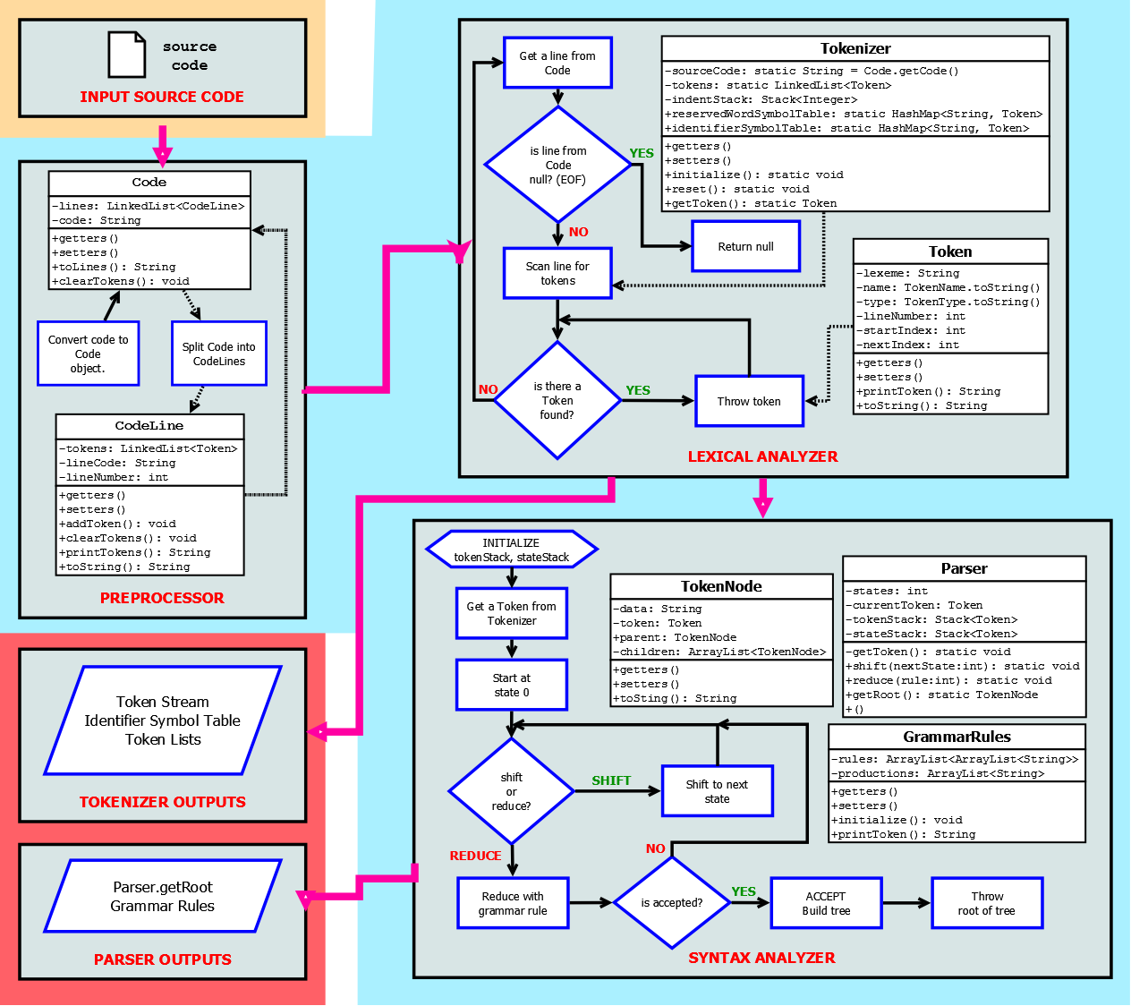

**Sample Programs and Parse Trees**

**Sample Program #1:**

#login sample_prog

#newsfeed

#ootc response

#ootc choice

#oots error = "Not in the choices"

#outbox "Hello World!\n"

#like

#ootf number1

#ootf number2

#outbox "\tA: ADDITION\n"

#outbox "\tB: SUBTRACTION\n"

#outbox "\tC: MULTIPLICATION\n"

#outbox "\tD: DIVISION\n"

#outbox "Select an operation: \n"; #inbox choice

#tweet (choice == 'A')

#ootf sum

#share sum number1 + number2

#outbox "Sum is = " areFriendsWith sum areFriendsWith "\n"

#retweet (choice == 'B')

#ootf difference

#share difference number1 - number2

#outbox "Difference is = " areFriendsWith difference areFriendsWith "\n"

#retweet (choice == 'C')

#ootf product

#share product number1 * number2

#outbox "Product is = " areFriendsWith product areFriendsWith "\n"

#retweet (choice == 'D')

#ootf quotient

#share quotient number1 / number2

#outbox "Quotient is = " areFriendsWith quotient areFriendsWith "\n";

#reply

#outbox error

#outbox "Again?: \n"; #inbox response

#status (response == 'y' | response =='Y')

#logout

**Parse Tree of Sample Program #1:**

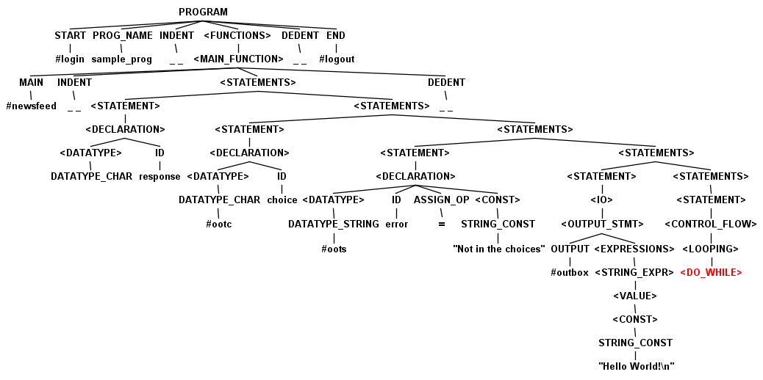

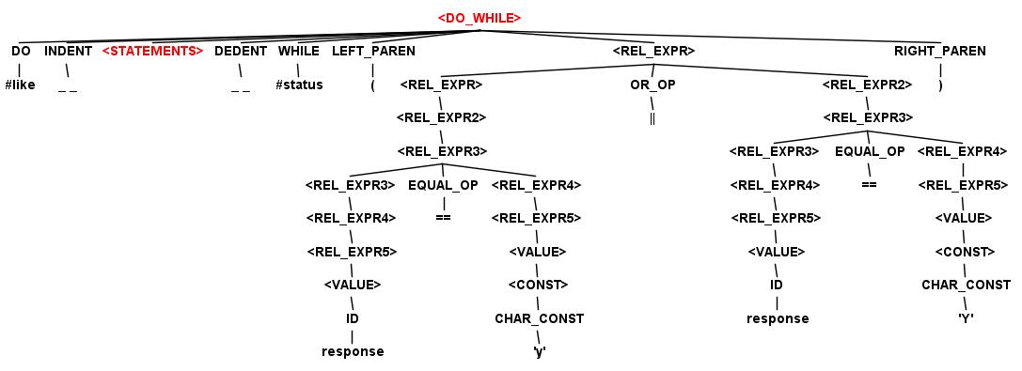

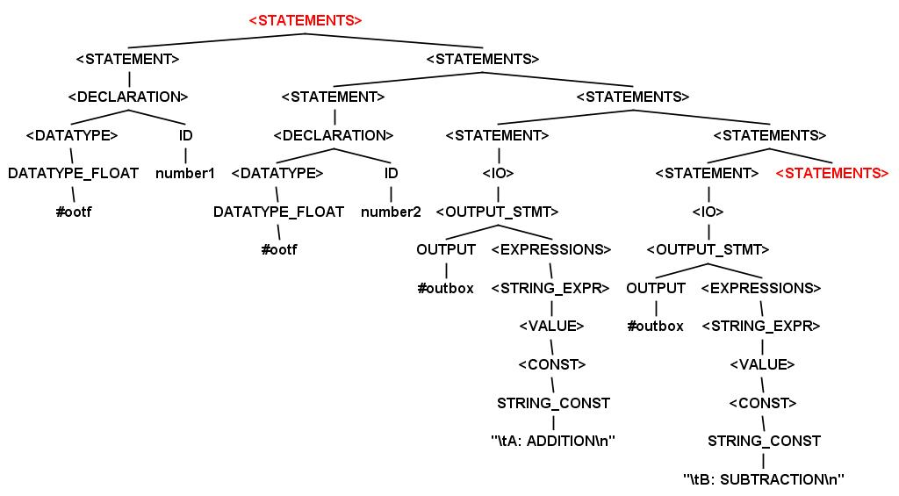

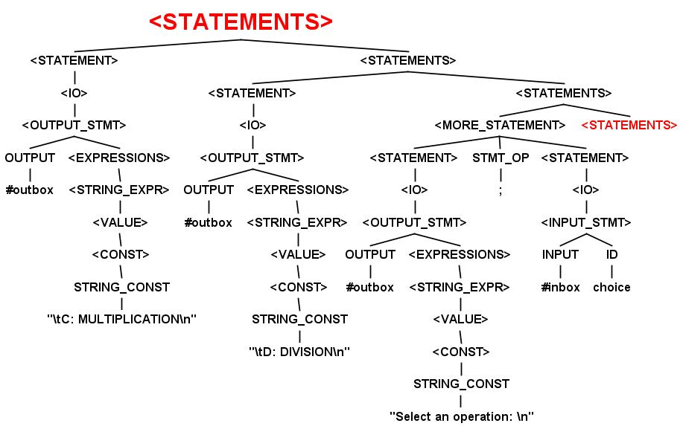

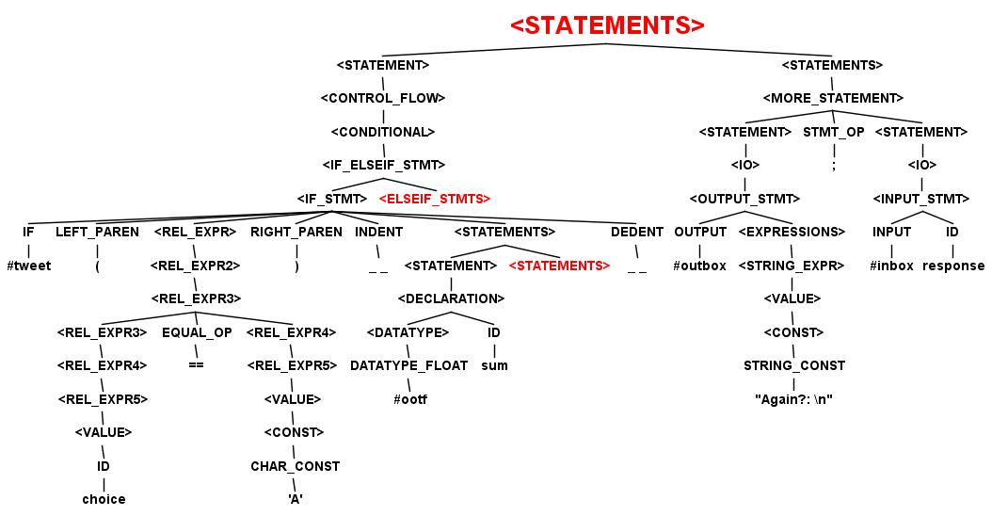

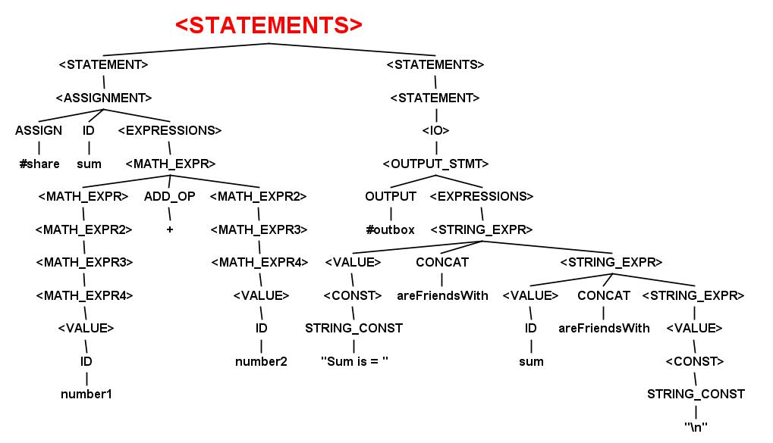

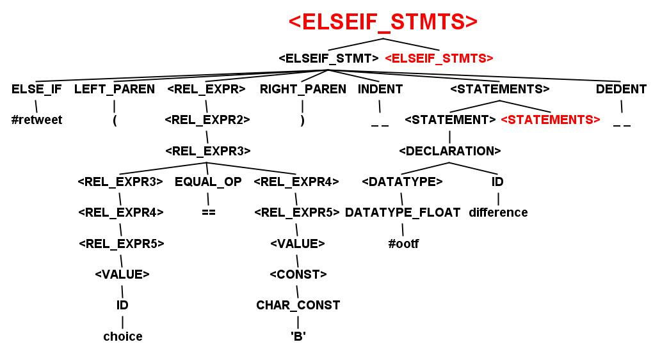

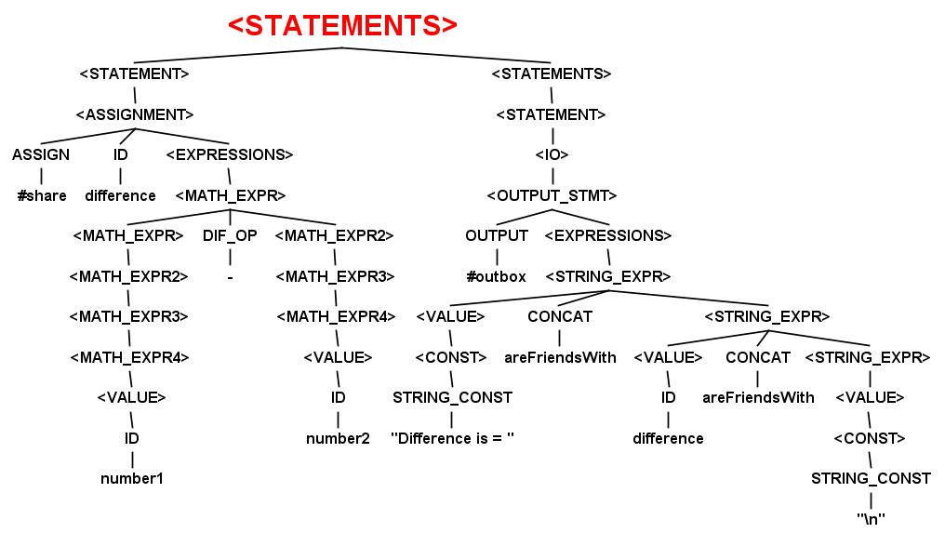

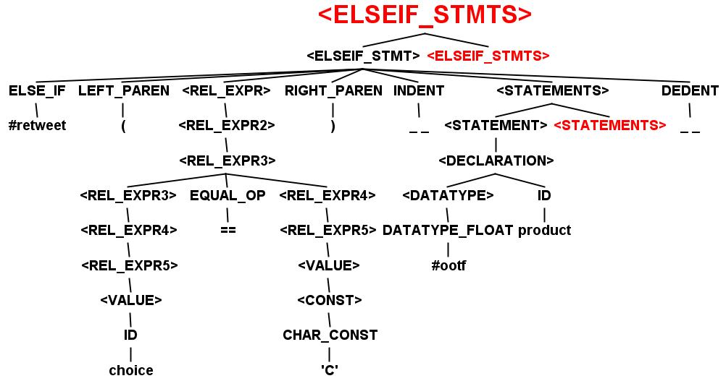

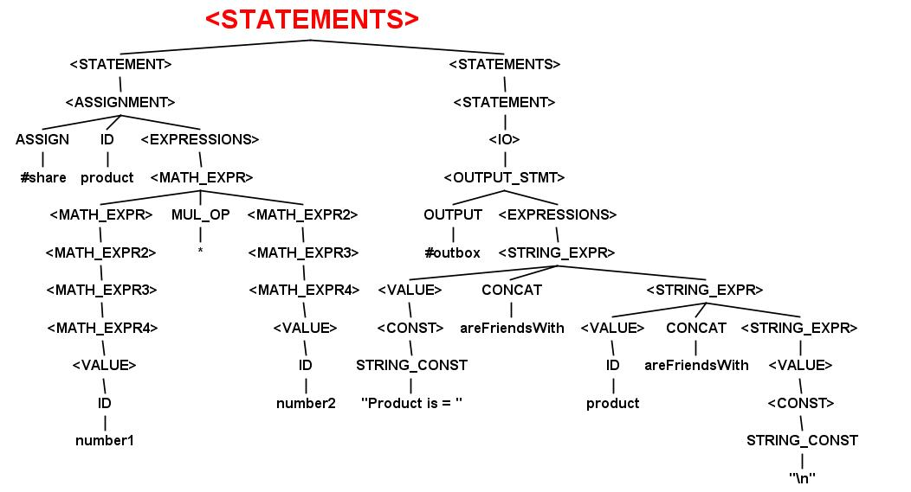

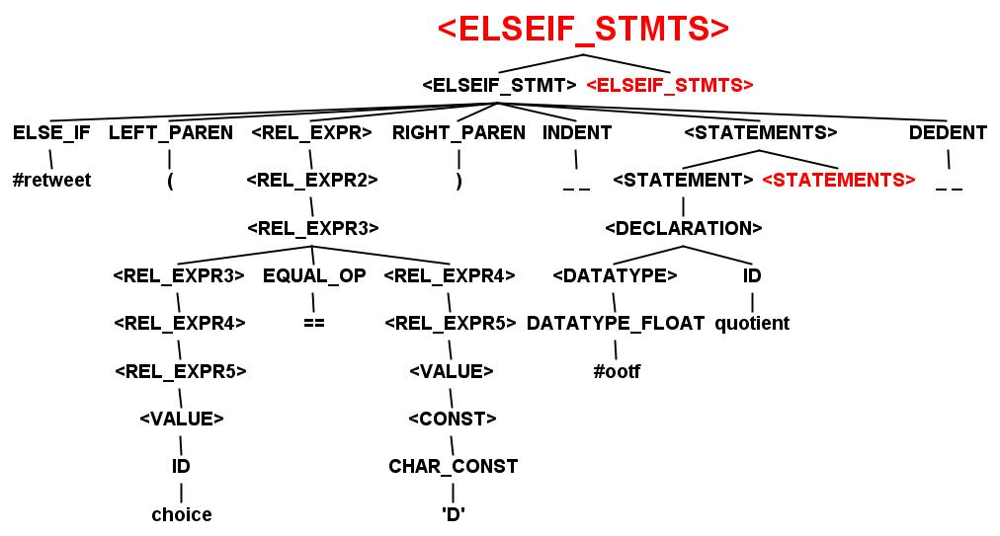

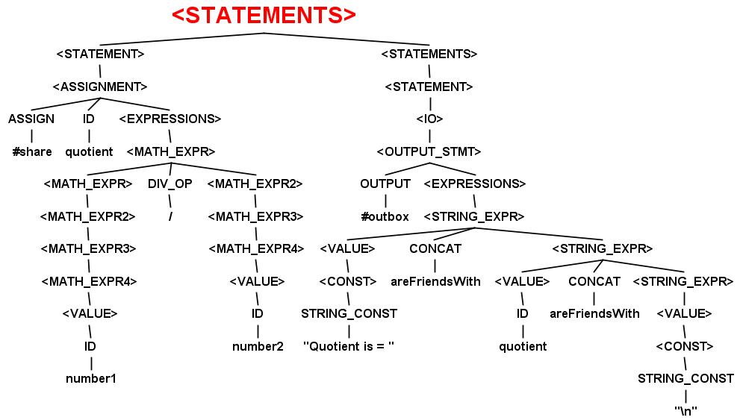

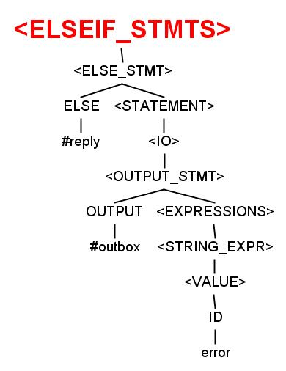

**Sample Program #2:**

#login sample_prog2

#newsfeed

#ooti grade

#outbox "Please Input grade: "

#inbox grade

#tweet (grade == 100)

#outbox "Excellent"

#unfollow

#outbox "That is great"

#retweet (grade > 70 && grade < 100)

#outbox "That is still awesome"

#follow

#reply #outbox "You fail"

#logout

**Parse Tree of Sample Program #2:**

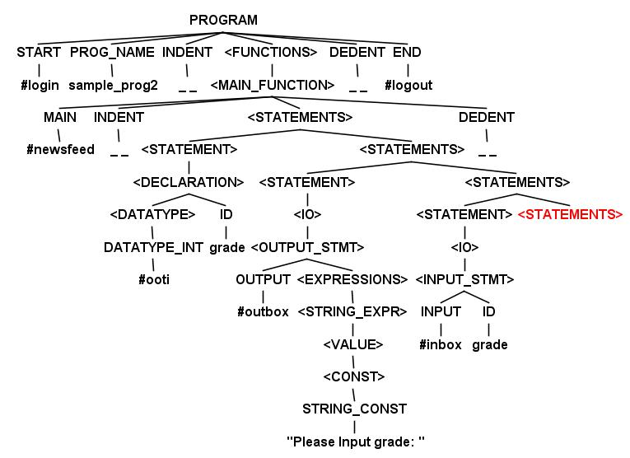

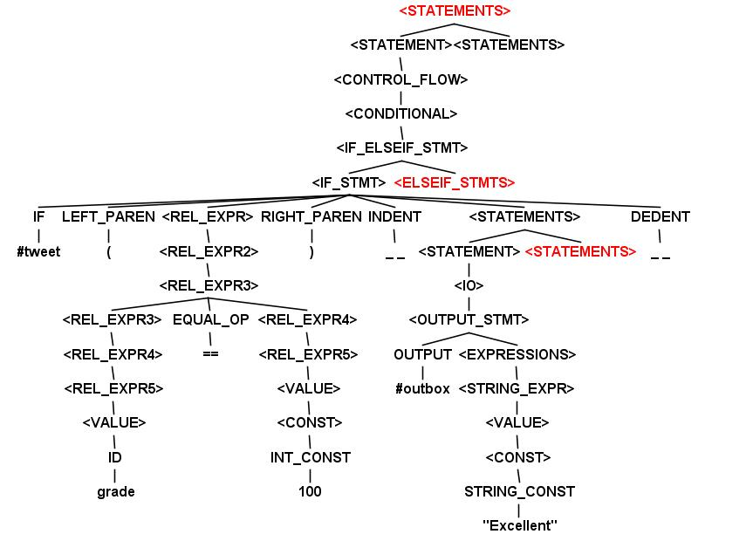

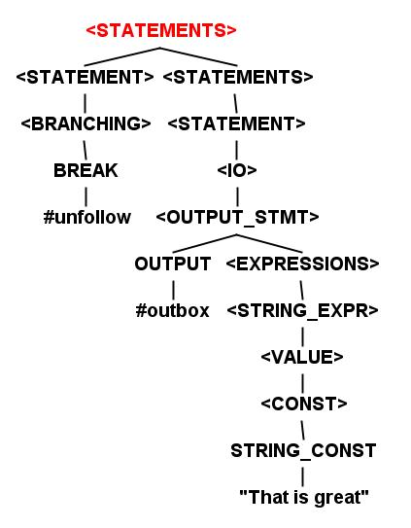

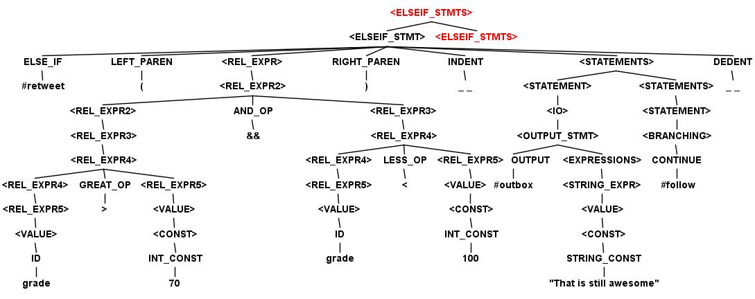

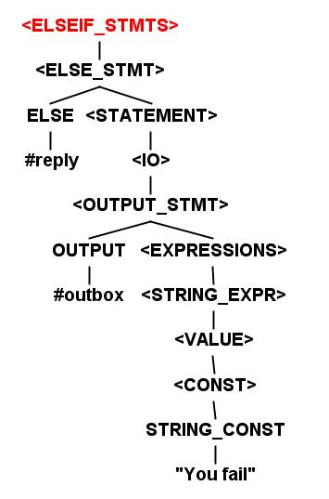

**Sample Program #3:**

#login sample_prog3

#newsfeed

#ooti num1 ; #ooti num2

#ootc choice

#oots error = "Not in the choices"

#outbox "Please input 1st number: "

#inbox num1

#outbox "Please input 2nd number: "

#inbox num2

#outbox "\tA: ADDITION\n"

#outbox "Select an operation: \n"; #inbox choice

#tweet (choice == 'A')

#ooti sum #share sum #trending addition ( num1 , num2 )

#trending ansAdd ( sum )

#reply

#outbox error

#ooti addition( #ooti a , #ooti b )

#ooti r

#share r a + b

#throwback r

#ootv ansAdd ( #ooti ans )

#outbox "Sum is = " areFriendsWith ans areFriendsWith "\n"

#logout

**Parse Tree of Sample Program #3:**

